

American International University-Bangladesh (AIUB)  
**Department of Computer Science  
Faculty of Science & Technology (FST)**

**Hospital Management System**

A Software Requirement Engineering Project Submitted

By

|  |  |  |  |
| --- | --- | --- | --- |
| **Semester: Spring_22_23** | | **Section:** | **Group Number:** |
| SN | Student Name | Student ID | Individual Marks |
| 01 | SADMAN SAKIB | 20-43159-1 |  |
| 02 | MD FARHAN UL ASIF | 20-43522-1 |  |
| 03 | **ARPON KARMAKAR** | **20-43493-1** |  |
|  |  |  |  |

Software Requirements Specification

for

<Hospital Management System >

Version 1.0 approved

Prepared by <

SADMAN SAKIB(20-43159-1)

MD FARHAN UL ASIF(20-43522-1)

ARPON KARMAKAR(20-43493-1)>

<American International University-Bangladesh >

<03.05.2023>

Table of Contents

Revision History 3

1. Introduction 4

1.1 Purpose 4

1.2 Document Conventions 4

1.3 Intended Audience and Reading Suggestions 5

2. Overall Description 6

2.1 Product Perspective 6

2.2 Product Functions 7

2.3 User Classes and Characteristics 10

2.4 Operating Environment 11

2.5 Design and Implementation Constraints 11

2.6 User Documentation 13

3. System Requirements 14

3.1 Functional Requirements (System Features) 14

3.2 Non-Functional/Quality Requirements 18

4. Design and Interface Requirements 19

4.1 UML Diagrams 19

4.2 Data Dictionary 20

4.3 UI/UX Design Specification 21

# Revision History

|  |  |  |  |
| --- | --- | --- | --- |
| **Name** | **Date** | **Reason for Changes** | **Version** |
| Product Functions | 28.04.2023 | Add more important function for requirement | Version1.0 |
|  |  |  |  |

# Introduction

## Purpose

The purpose of the Hospital Management System project is to provide a comprehensive and efficient online platform that enables patients, doctors, and admin to manage hospital-related tasks seamlessly. The website will serve as a central hub for patients to book appointments, view their medical history, and receive reminders for upcoming appointments. For doctors, the website will provide a platform to manage their schedules, view patient information, and update medical records. The website will also enable administrators to manage resources, assign tasks to staff members, and generate reports on hospital operations.

## Document Conventions

The following conventions have been used in this SRS project for the Hospital management system platform:

1. Requirements are identified by a unique identifier in the format of "REQ-X," where X is a

unique number.

2. Use cases are identified by a unique identifier in the format of "UC-X," where X is a unique

number.

3. All requirements and use cases are described using a structured format that includes a brief

description, input data, processing requirements, output data, and any relevant constraints.

4. Non-functional requirements are identified separately and described using a structured format

that includes a brief description and any relevant constraints.

5. The terms "user" and "administrator" are used to refer to the different types of system users.

6. All acronyms are spelled out at their first use in the document, followed by the acronym in

parentheses. Subsequent references to the same acronym use the acronym only.

7. The document follows a hierarchical structure, with major headings denoted by numbers and

subheadings denoted by letters.

8. The document is written in plain language and follows a consistent writing style throughout.

## Intended Audience and Reading Suggestions

The intended audience for a software requirements specification (SRS) document includes all stakeholders involved in the development, testing, and deployment of the software. This includes software developers, testers, project managers, business analysts, and clients or customers who will be using the software. Here are some reading suggestions for different audiences:

**Developers and testers**: These stakeholders are directly involved in the development and testing of the software. They should read the SRS document in detail and focus on the functional and non-functional requirements, use cases, and system constraints. They should also refer to any relevant technical documentation or specifications.  The team was responsible for testing the system to ensure it meets the desired quality standards.

**Project managers and business analysts**: These stakeholders are responsible for overseeing the development of the software and ensuring that it meets the client's requirements. They should read the SRS document to gain a high-level understanding of the software's features, capabilities, and limitations. They should focus on the project timeline, budget, and any risks associated with the development process.

**Clients or customers**: These stakeholders will be using the software, and therefore, they need to have a clear understanding of its features, functionalities, and limitations. They should read the SRS document to gain a comprehensive understanding of how the software will work and what they can expect from it. They should focus on the functional and non-functional requirements, use cases, and any relevant user documentation.

**Non-technical stakeholders:** These stakeholders may not have a background in software development and may find it challenging to read the SRS document. Therefore, it is important to provide a summary or executive summary of the document that explains the software's purpose, features, and limitations in non-technical terms. This can help non-technical stakeholders understand the software's capabilities and how it will benefit them.

**Administrators:** The team responsible for managing and maintaining the system.

**End-users**: The individuals who will be using the system to book ride-sharing services, order food, and schedule courier services.

**Project Managers:** The individuals responsible for overseeing the development, testing, and deployment of the system.

# Overall Description

## Product Perspective

The hospital management system is a software product designed to streamline various hospital-related activities such as appointment scheduling, patient care, medical history management, inventory management, and billing. The system is designed to be user-friendly, secure, and efficient, catering to the needs of different user classes such as patients, doctors, and administrators.

The hospital management system can be viewed as a comprehensive solution that provides end-to-end management of hospital-related activities. The system is designed to enhance the overall hospital experience for patients, staff, and administrators by providing easy access to critical information and automating various tasks.

The hospital management system is designed to be highly customizable, allowing hospitals to configure the system according to their specific requirements.

In conclusion, the hospital management system is a comprehensive software product that offers a wide range of functionalities to streamline hospital operations. With its user-friendly interface, customization capabilities, efficiency, data security, and scalability, it is a valuable solution for hospitals looking to optimize their operations, provide better patient care, and comply with data protection regulations.

## Product Functions

**Login/Sign in:**

Allow users to securely log in to their accounts by providing their email/username and password.

Validate user credentials and grant access to their account if they are correct.

Provide appropriate error messages if the user enters incorrect credentials or if their account has been disabled.

**Registration/Signup:**

Allow new users to sign up for an account by providing their personal information such as name, email, password, and other required details.

Provide appropriate error messages if the user enters invalid information or if their email address is already registered.

**Forget Password**:

Allow users to reset their password if they forget it.

**Change Password:**

Allow users to change their password after they have successfully logged in.

Verify the user's old password before allowing them to set a new one.

Provide appropriate error messages if the user enters an incorrect old password or if their new password is not strong enough.

**Profile (Update & View):**

Allow users to view and update their profile information such as their name, email, and other details.

Provide appropriate error messages if the user enters invalid information or if their email address is already registered.

Allow users to update their personal information.

**User Management (Admin):**

Allow authorized staff(Admin) to create, view, update and delete user accounts.

Ensure that users have appropriate access rights based on their roles.

Provide appropriate error messages if the user enters invalid information.

**Appointment Management (Admin):**

Allow authorized staff **(Admin)** to view, create and update all appointments and manage appointment scheduling.

**Cabin/Bed Allotment (Admin):**

Allow authorized staff **(Admin)** to manage the allocation of cabins/beds to patients.

**Medicine Management (Admin):**

Allow authorized staff **(Admin)** to create, view, update, and delete medicine records.

Ensure that the medicine inventory is up-to-date and that stock levels are maintained.

Provide appropriate error messages if the user enters invalid information.

**Blood Bank Report Management (Admin):**

Allow authorized staff **(Admin)** to create, view, update, and delete blood bank reports.

Ensure that the blood bank inventory is up-to-date and that stock levels are maintained.

Provide appropriate error messages if the user enters invalid information.

**View Operation Report:**

Allow authorized staff to view the operation reports.

**Take & Cancel an Appointment (Patients):**

Allow patients to take and cancel their appointments with doctors.

Ensure that the appointment scheduling is done in an efficient manner based on the patient's medical condition and the availability of doctors.

Provide appropriate error messages if the patient enters invalid information.

**View and Search the Doctor's Daily Schedule (Patients):**

Allow patients to view the daily schedule of doctors.

Provide a search function to allow patients to find doctors based on their name, specialization, or availability.

Ensure that the doctor's schedule is up-to-date and that patients are able to schedule appointments in an efficient manner.

**View Treatment Cost (Patients):**

Allow patients to view the cost of various treatments and procedures.

Provide a comprehensive list of treatments and their associated costs.

Ensure that the treatment cost information is up-to-date and accurate.

**View Services List (Patients):**

Allow patients to view a list of hospital services and facilities.

Provide a comprehensive list of hospital services and facilities available to patients.

Ensure that the services list is up-to-date and accurate.

**View Medical History & Prescriptions (Patients):**

Allow patients to view their medical history and previous prescriptions.

Provide a comprehensive list of past medical treatments, diagnoses, and prescriptions.

Ensure that the medical history and prescription information is up-to-date and accurate.

**Make Payment (Patients):**

Allow patients to make payments for their medical treatment and services.

Provide secure payment options for patients to make payments online or through other payment methods.

Ensure that the payment process is user-friendly and efficient.

**View + Cancel Appointments (Doctor):**

Allow doctors to view and cancel their appointments.

**View Patient Medical History + Add Prescriptions (Doctor):**

Allow doctors to view a patient's medical history and add prescriptions.

Provide a comprehensive list of past medical treatments, diagnoses, and prescriptions.

Ensure that the medical history and prescription information is up-to-date and accurate.

**Provide Meditation for Patients (Doctor):**

Allow doctors or authorized staff to provide meditation and relaxation techniques for patients.

**Operation + Appointment Schedules Management (Doctor):**

Allow authorized staff **(Doctor)** to manage the operation and appointment schedules.

Ensure that the schedules are up-to-date and that they provide a comprehensive overview of the clinic's activities.

Provide appropriate error messages if the staff is not authorized to manage the .

**Operation Report Management (Doctor):**

Allow authorized staff **(Doctor)** to create, view, update, and delete operation reports.

Ensure that the operation reports are up-to-date and that they provide a comprehensive overview of the clinic's activities.

**Charge Details:**

Allow authorized staff to manage the charge details for various medical treatments and services.

**Online consulting (Doctor):**

Allow doctors to generate a Google Meet room link for online consultations.

Ensure that patients are able to connect with doctors remotely in a secure and efficient manner.

**Logout:**

Allow users to securely log out of their account when they have finished using the system . Invalidate their session and clear any sensitive data to prevent unauthorized access to their account.

 The hospital management system should be user-friendly, secure, and efficient, providing a seamless experience for patients, staff, and administrators to manage their accounts and personal information. appointments, medical records, medical appointments, treatment, and payments and other hospital-related activities.

## User Classes and Characteristics

**Admin:**

**Characteristics:** The admin is responsible for managing the overall hospital management system, including user access, system settings, data management, and security.

**Responsibilities**: The admin can create and manage user accounts, configure system settings, manage data backups, and ensure data security.

**Doctor**:

**Characteristics**: A doctor is responsible for managing patient care, diagnosing medical conditions, and prescribing medications.

**Responsibilities**: The doctor can view patient medical records, update patient information, diagnose medical conditions, and prescribe medications.

**Patient**:

**Characteristics**: A patient is a person who receives medical care and treatment from a hospital or clinic. They can create and manage user accounts and others activities.

**Responsibilities**: The patient can view their medical records, schedule appointments, view treatment plans, and make payments for medical services.

Overall, the Hospital Management System should be designed to meet the needs of each user class, with features and functions that are tailored to their specific roles and responsibilities. The system should provide a secure and efficient way for users to access patient information, manage appointments, and ensure effective patient care.

## Operating Environment

This software is web-based software.

The minimum set of browsers that must be supported is:

1. Apple Safari 7+
2. Google Chrome 44+
3. Microsoft Internet Explorer 10+
4. Mozilla Firefox 40+

## Design and Implementation Constraints

**Constraints The design time constraints are:**

1. The Hospital Management System must ensure the security and privacy of all patient data and information. This requires strict data access controls, secure authentication methods, and encryption of sensitive data.
2. The system should store all users' data without problems. Associating this data.
3. This ensures the safety of the data.
4. This Software System is developed in Microsoft Visual Studio, Apache XAMPP and MYSQL with PHP, CSS, JavaScript, jQuery, and HTML. These should be considered for the maintenance of this software

**User Interface Constraints**

Using this system is simple and intuitive. A user familiar with basic browser navigation skills should be able to understand all functionality provided by the system.

**Hardware Constraints**

The system should work on desktop/laptop computers and mobile devices which supports JavaScript and HTML5.

**Software Constraints**

The system will be intended to run on Apple Safari 7 and above, Firefox 40 and above, Google Chrome 44 and above and Internet Explorer 10 and above.

**Data Accuracy**

The system maintains accurate and up-to-date data, including patient records, appointment schedules, medical histories, and inventory levels.

**Performance**

The system performs efficiently and reliably, with fast response times and minimal downtime. This requires optimization of database queries, network bandwidth, and server resources.

**Maintenance**

The system be easy to maintain and update, with minimal downtime and disruption to hospital operations. This requires version control, backup and recovery procedures, and testing before deployment of updates.

**Data Management Constraints**

System shall be able to interface with other components according to their specifications.

**Operational Constraints**

The system is limited by its operating server in terms of the maximum number of users .it can support at a given time.

## User Documentation

**Registration:**

Verify that new users can create accounts by providing their name, email address, password, and other required details.

If the user submits incorrect information or if their email address is already registered, provide the correct error message.

**Login:**

Allow users to securely access their accounts by entering their password, email, and username. Verify the user's credentials, and if they're correct, give them access to their account. If the user inputs incorrect login information or if their account has been deactivated, provide the proper error messages.

**Profile Update & View:**

Allow users to access and edit their profile data, including their name, email address, and other specifics. If the user submits incorrect information or if their email address is already registered, provide the proper error messages. Permit users to modify their personal data.

**View Operation Report:**

Allow authorized staff to view the operation reports.

**Take & Cancel an Appointment:**

Allow people to book and reschedule healthcare appointments. Make sure that scheduling appointments is done effectively depending on the patient's health and the availability of doctors. If a patient inputs false information, provide the proper error messages.

**View and Search the Doctor's Daily Schedule:**

Allow patients to see the physicians' daily schedules. Give patients a search option so they may look for doctors by name, specialty, or availability. Ensure that the patient's ability to arrange an appointment effectively and that the doctor's schedule is up to date.

**View Treatment Cost :**

Permit patients to see the price of various procedures and treatments. List all available therapies together with their related prices. Make sure the cost of treatment information is correct and up to date.

**View Services List:**

Allow patients to browse a list of the hospital's amenities and services. List all of the patient-accessible hospital services and amenities in detail. Make sure the services list is correct and up to date.

**View Medical History &  Prescriptions :** Allow patients to view their medical history and previous prescriptions.

**Make Payment :**

Allow patients to pay for their services and medical care.

Patients should have access to safe payment choices for making online or other types of payments. Make sure the payment procedure is simple to use and quick.

**Logout:**

When a user is done using the system, allow them to safely log out of their account. To avoid unwanted access to their account, invalidate their session and delete any private information.

# System Requirements

## Functional Requirements (System Features)

**1.  Registration:**

1.1  When users will fill up the registration form they should give only valid information.

1.2 They have to give their correct email address, phone number, Date of birth .

1.3 Their information will be verified later.

**Priority Level:** High  
 **Precondition:** This registration is only for patients.

**2. Login**

1.1 User login into the system with a username and password according to registration.

1.2  The login information will be cross-checked against database records.

1.3 If the login is successful, the user account's home page is displayed.

1.4  if the username or password are entered incorrectly then the system will produce a error message .

**Priority Level:** High  
 **Precondition:** The user has a valid username and password

**3.Profile Update & View:**

3.1 All user can modify their profile.

## 3.2 User must fill all the required info.

**Priority Level:** Medium   
 **Precondition:** user has to be valid.

**4. Appointment management**

4.1. Only for valid admin.

4.2. An admin can modify any appointment.

**Priority Level:** Medium   
 **Precondition:** user has to be a valid admin.

## 5. Blood management

5.1. Only for valid admin.

5.2. An admin can view the blood bank list and also modify them

**Priority Level:** Medium   
 **Precondition:** user has to be a valid admin.

**6. View and Search the Doctor's Daily Schedule**

6.1. Any patient (users)  can view this page.

6.2. Doctors' daily schedules were previously stored in the database.

**Priority Level:** Low  
 **Precondition:** user must log in to see the doctor's schedule.

**7. View the Services List**

7.1. Any patient (users)  can view this page.

7.2. All the services provided by the hospitals were previously stored in the database.

**Priority Level:** Low  
 **Precondition:** user must log in to see the services list.

**8. View Patient Medical History & Add Prescriptions**

8.1. Allow doctors to view a patient's medical history and add prescriptions.

8.2. Doctors can Provide a comprehensive list of past medical treatments, diagnoses, and prescriptions.

**Priority Level:** High  
 **Precondition:** user must be a valid doctor

**9. Operation & Appointment Schedules Management**

9.1. Allow authorized staff **(Doctors)** to manage the operation and appointment schedules.

9.2. Provide appropriate error messages if the staff is not authorized to manage the

**Priority Level:** High

**Precondition:** user must be a valid doctor

**10. User Management**

10.1. Allow authorized staff(Admin) to create, view, update and delete user accounts.

10.2. Ensure that users have appropriate access rights based on their roles.

10.3. Provide appropriate error messages if the user enters invalid information.

**Priority Level:** High  
**Precondition:** user must be a valid Admin.

## Non-Functional/Quality Requirements

## Security: The system should be designed to protect the confidentiality, integrity,    and availability of patient and healthcare data, and comply with relevant regulations and standards.

## Priority Level: High Precondition: N/A

## Usability: The system should be easy to learn and use, with a consistent and intuitive user interface, and provide appropriate feedback to users.

## Priority Level: Medium Precondition: N/A

## Reliability: The system should be reliable and operate without significant downtime or data loss, and provide mechanisms for fault tolerance, error recovery, and data backup.

## Priority Level: High Precondition: N/A

## Scalability: The system should be able to scale up or down to accommodate changes in user demand, data volume, and system complexity.

## Priority Level: High Precondition: N/A

## Performance: The system should be able to handle a large number of concurrent users, transactions, and data without significant degradation in response time or system availability.

## Priority Level: Medium Precondition: N/A

## Interoperability: The system should be able to exchange data and communicate with other healthcare systems, such as electronic health record systems, medical devices, and other healthcare applications.

## Priority Level: Medium Precondition: N/A

## Performance Monitoring: The system should provide mechanisms for monitoring system performance and detecting and responding to performance issues.

**Priority Level:** High  **Precondition:** N/A

# Design and Interface Requirements

## UML Diagrams

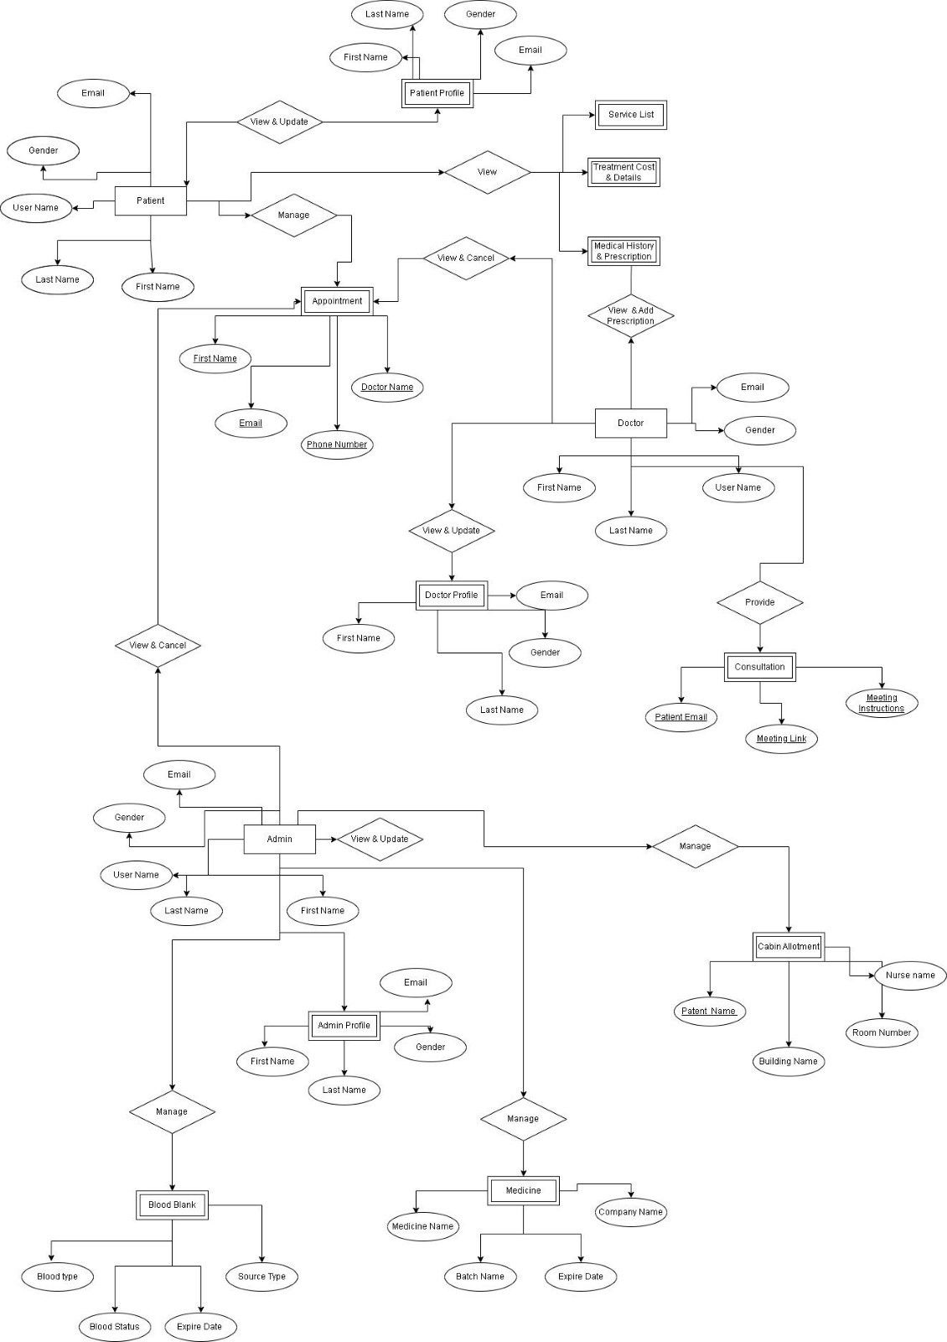

## Data Dictionary

**User**

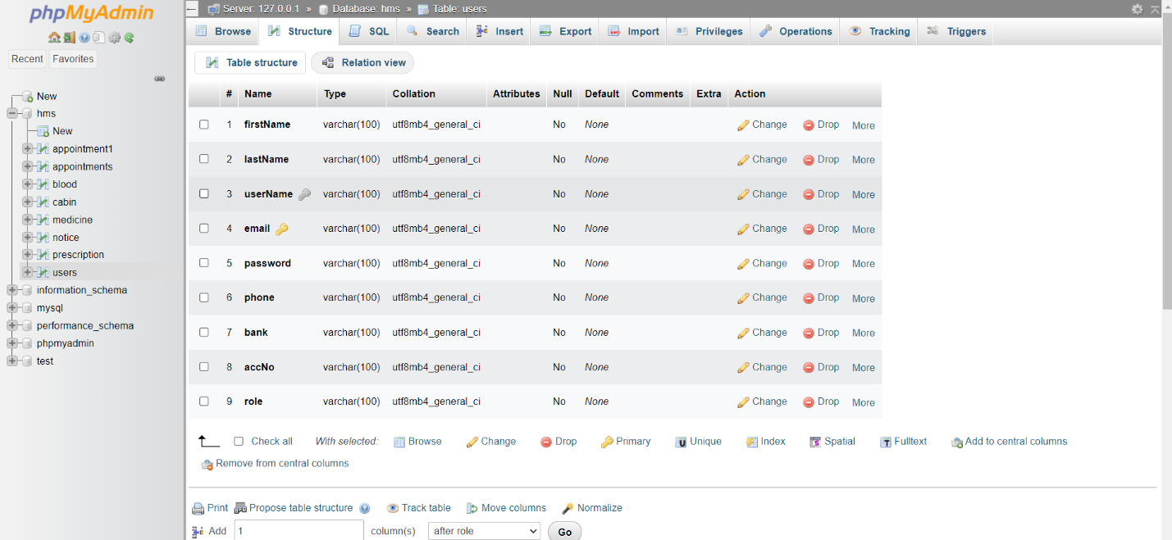

**Appointment**

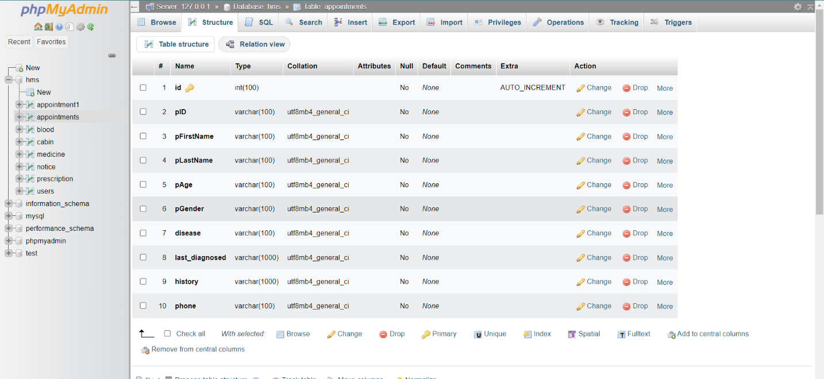

**Blood**

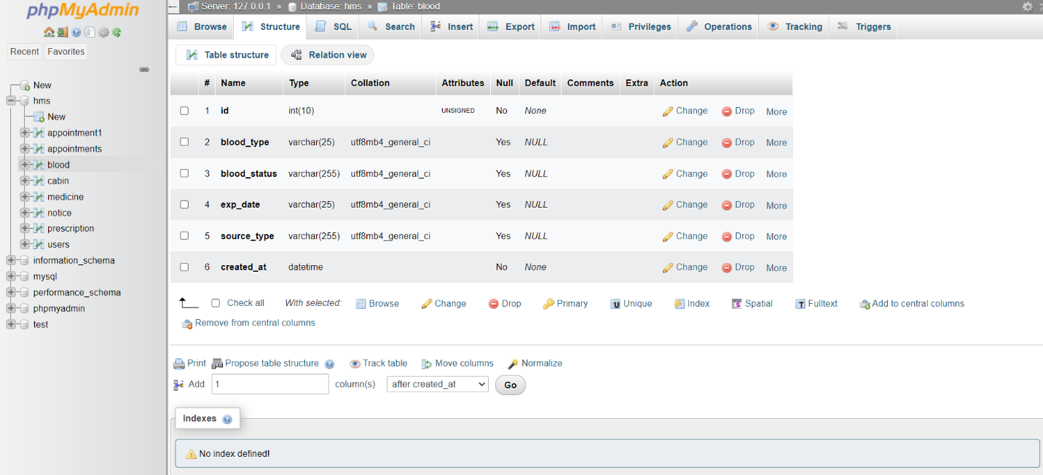

## UI/UX Design Specification



